Contents

Install Spark Worker 2

Download Spark Worker 2

Extract to Folder 3

Install Apache Spark 3

Download Apache Spark 3

Extract to Apache Spark 3

SET Environment Variables 4

SET System Variables 5

How to Run .NET UDFs 5

Start Spark-submit 5

To Debug in Visual Studio 6

Useful URLS 6

## Install Spark Worker

### Download Spark Worker

<https://github.com/dotnet/spark/releases>

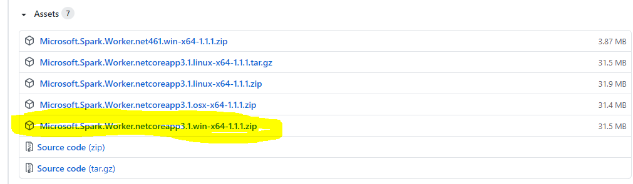

### Extract to Folder

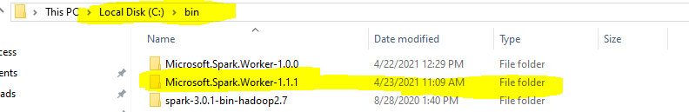

## Install Apache Spark

### Download Apache Spark

https://dotnet.microsoft.com/learn/data/spark-tutorial/install-spark

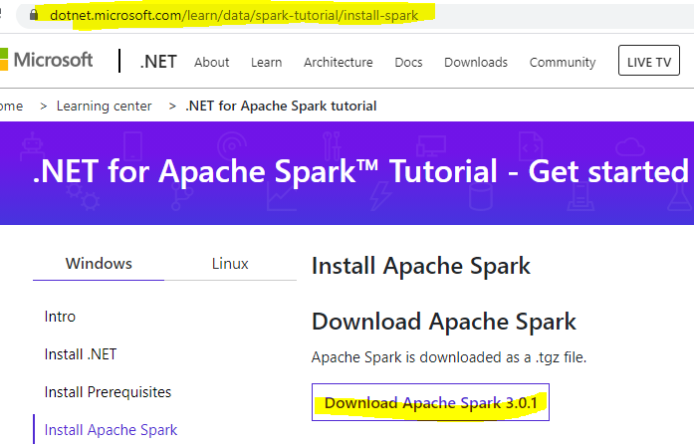

### Extract to Apache Spark

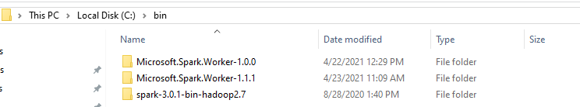

## SET Environment Variables

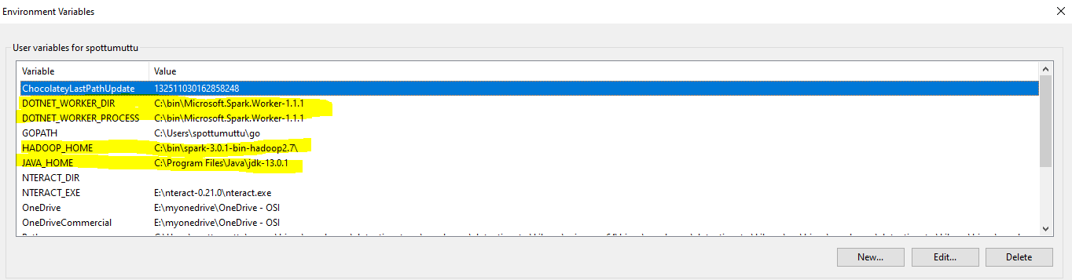

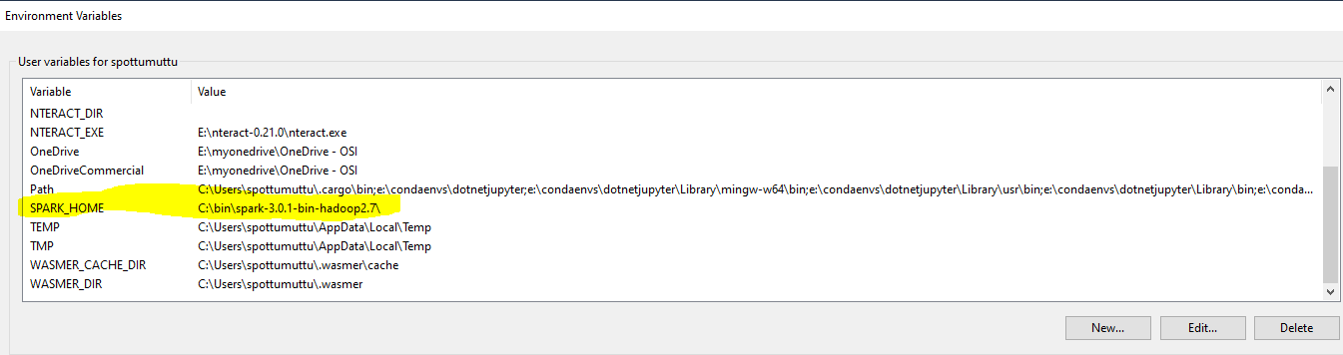

## SET System Variables

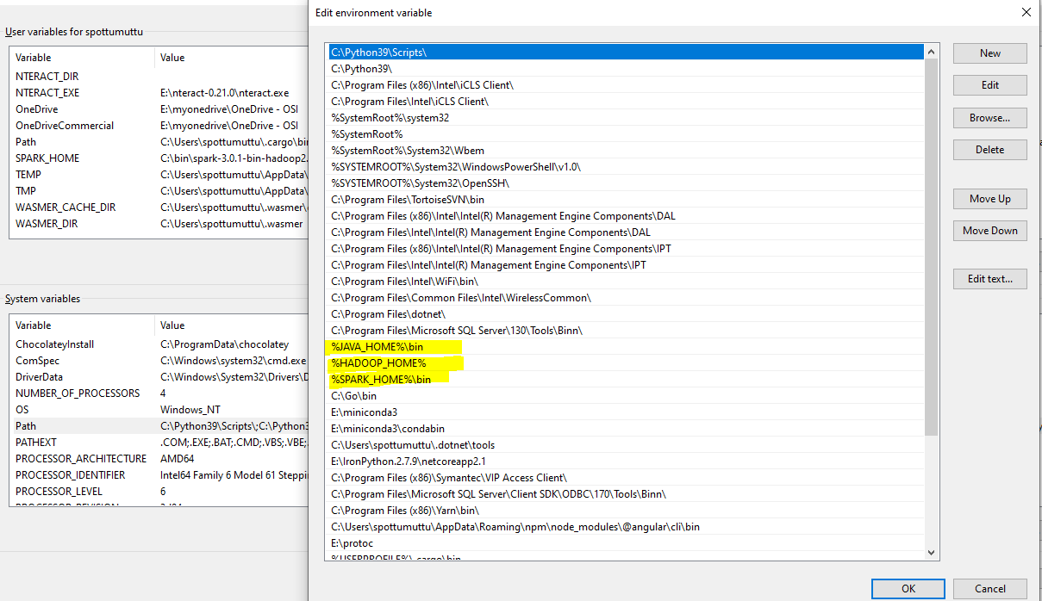

## How to Run .NET UDFs

****It is important to run spark-submit from this folder “bin\Debug\netcoreapp3.1” other wise .NET UDF’s will not work.

### Start Spark-submit

EX:

PS E:\mygithub\sparkdotnetdemos\HelloSpark\bin\Debug\netcoreapp3.1> spark-submit --class org.apache.spark.deploy.dotnet.DotnetRunner --master local microsoft-spark-3-0_2.12-1.1.1.jar debug

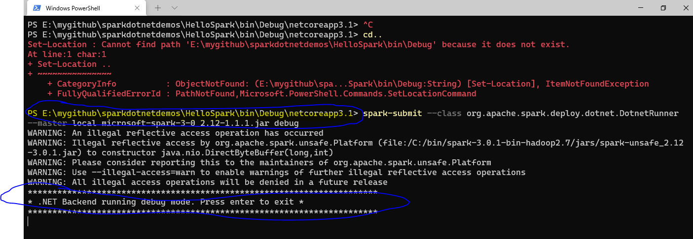

### To Debug in Visual Studio

Open the application code (ex: hellospark) in visual studio and set break point and enjoy debugging

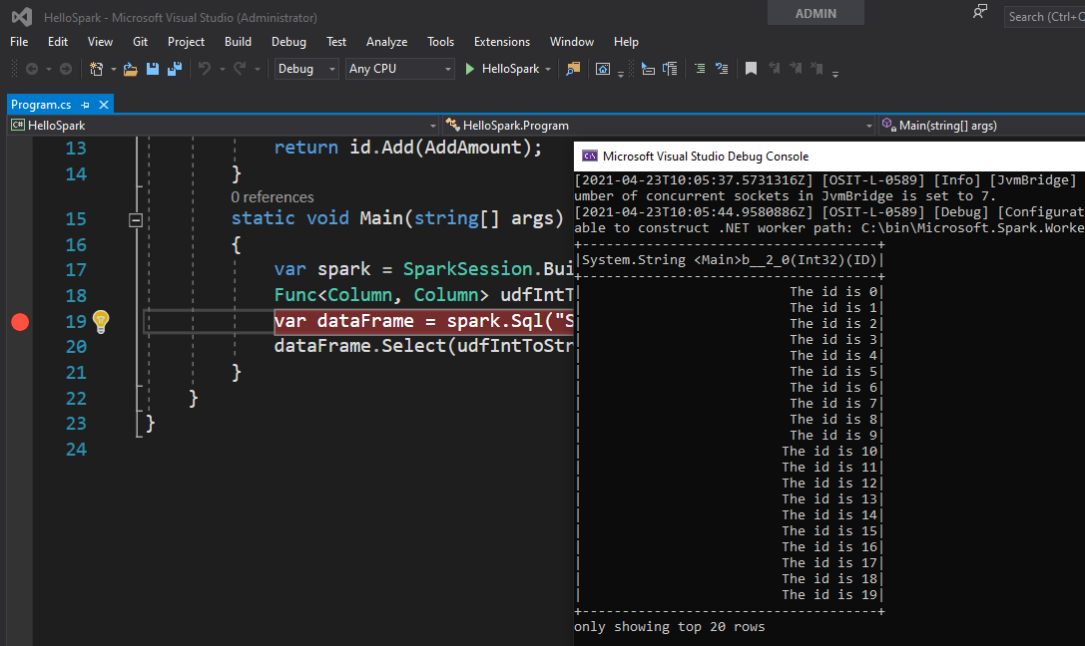

## Useful URLS

<https://dotnet.microsoft.com/learn/data/spark-tutorial/install-spark>

<https://github.com/dotnet/spark/releases>

<https://github.com/dotnet/spark#get-started>

<https://github.com/dotnet/spark/issues/242>

<https://github.com/dotnet/spark/issues/177>

<https://github.com/dotnet/spark/tree/main/deployment#preparing-your-spark-net-app>

Introducing .NET for Apache Spark Book

<https://www.apress.com/gp/book/9781484269916>

https://www.red-gate.com/simple-talk/dotnet/net-development/apache-spark-for-net-developers/